COIT11238 – TCP/IP Principals and Protocals

Term 1, 2026

Week 2

Name: Elish Niraula
ID: 12313870
Lecturer / Tutor: Suresh Talam

COIT12206 Week 4 Tutorial Report

Task 1: Static Routing
Static routing was configured using manually assigned IP addresses across two subnets. Routing was enabled on the router and connectivity between hosts was successfully verified using ping.
Screenshots of all:
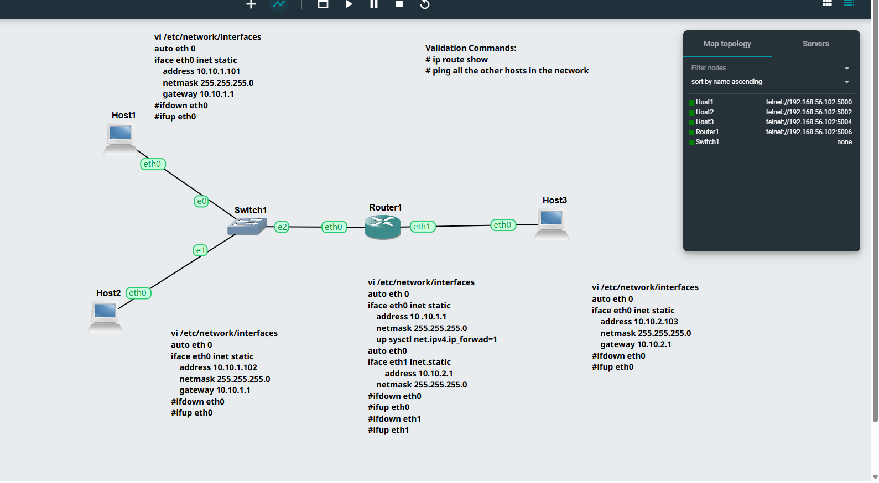

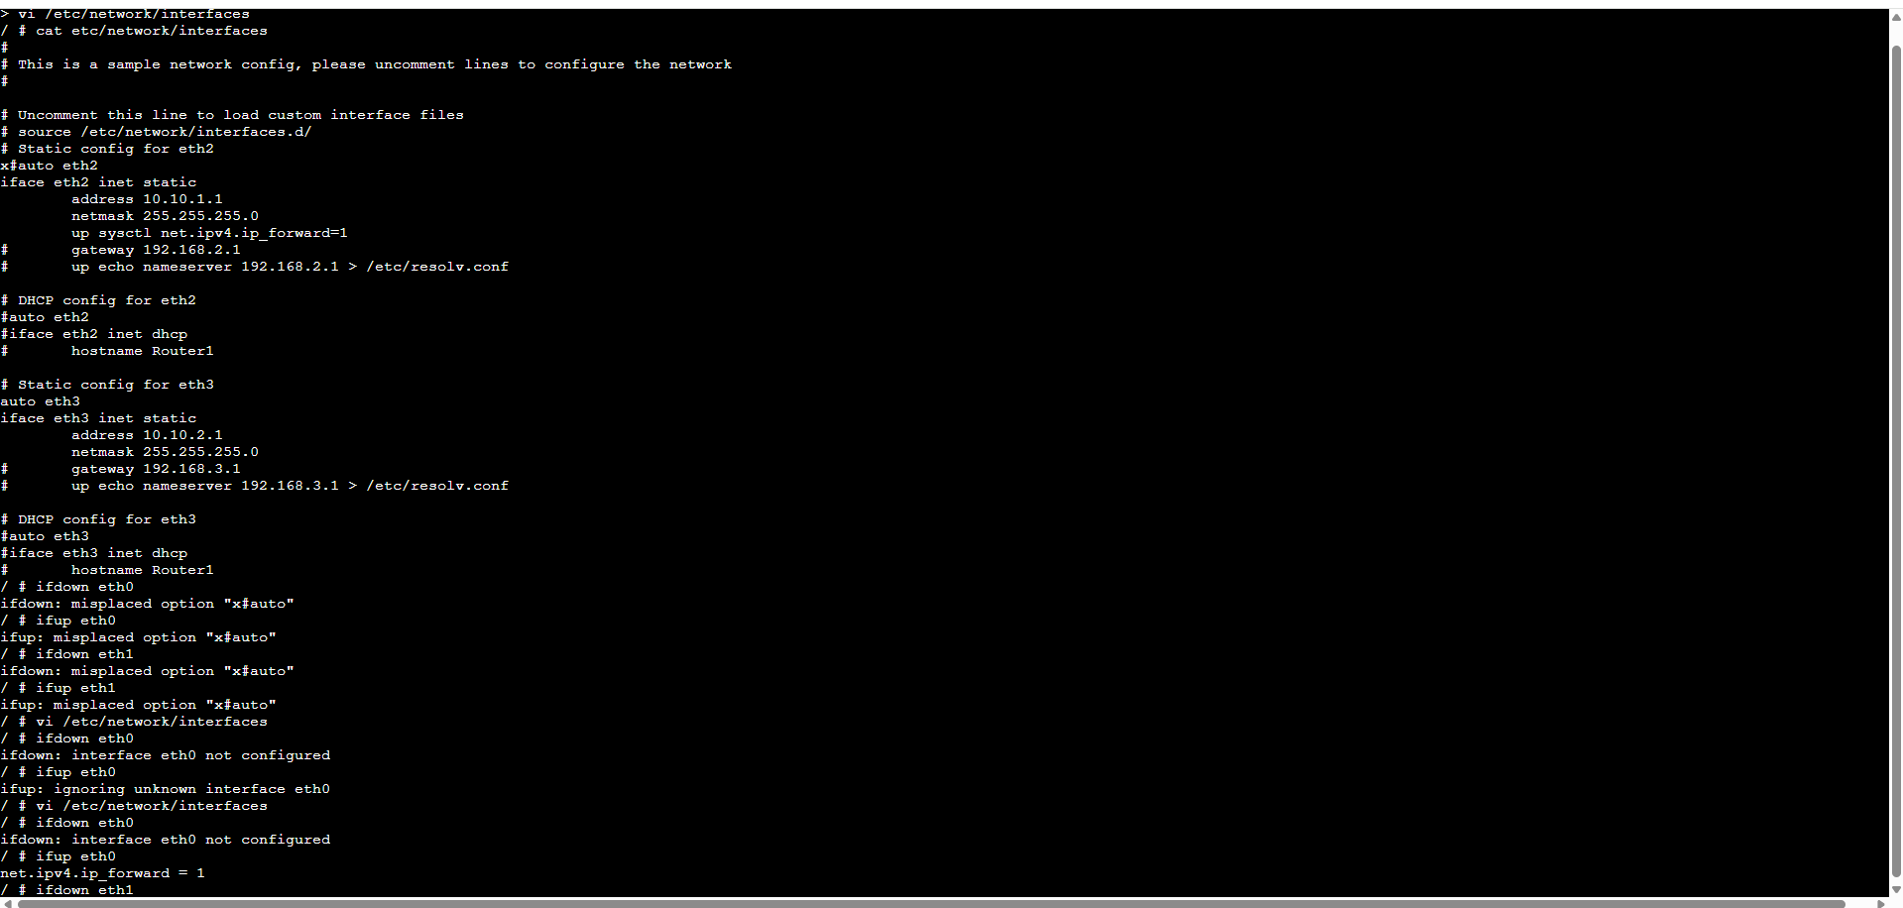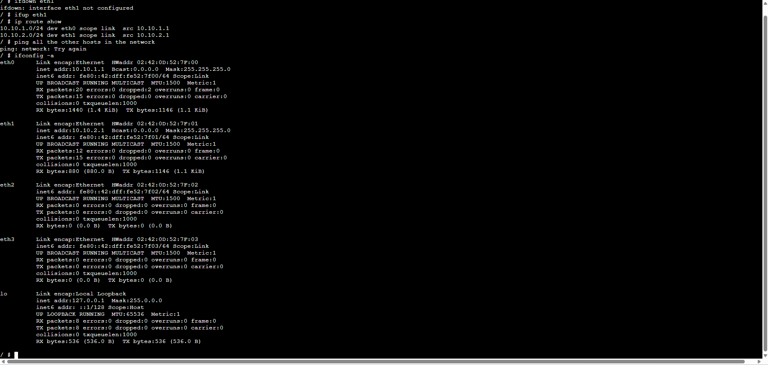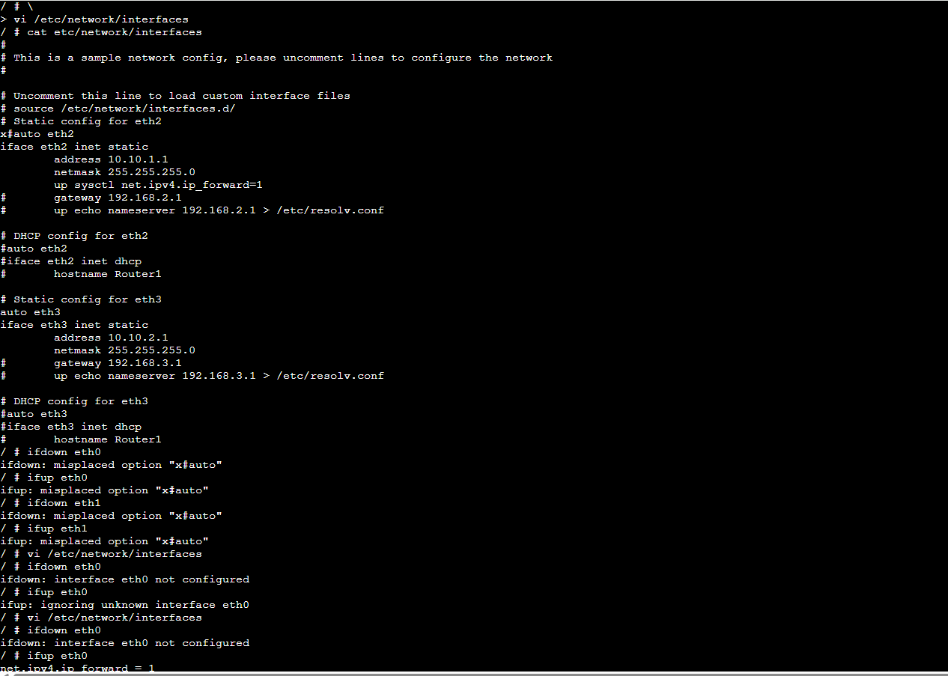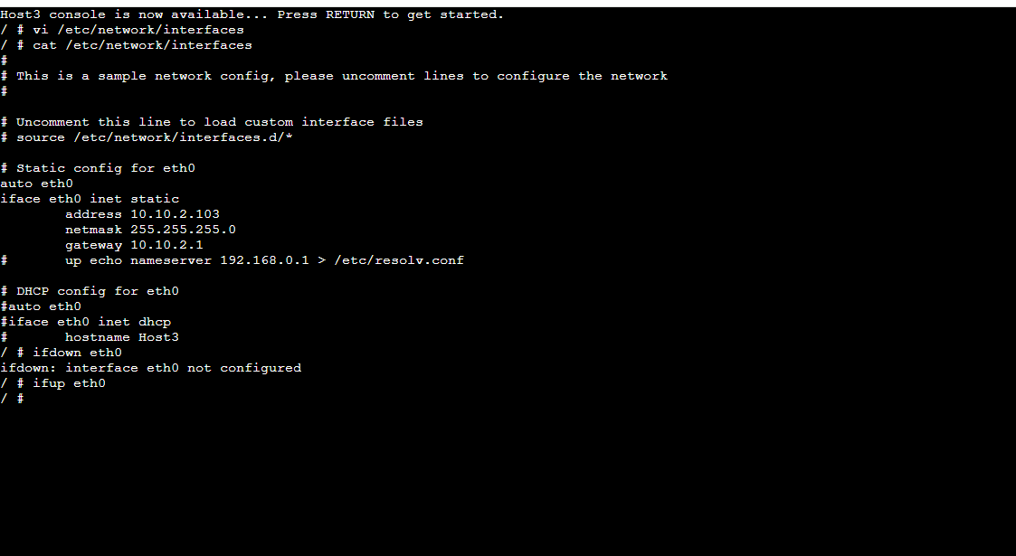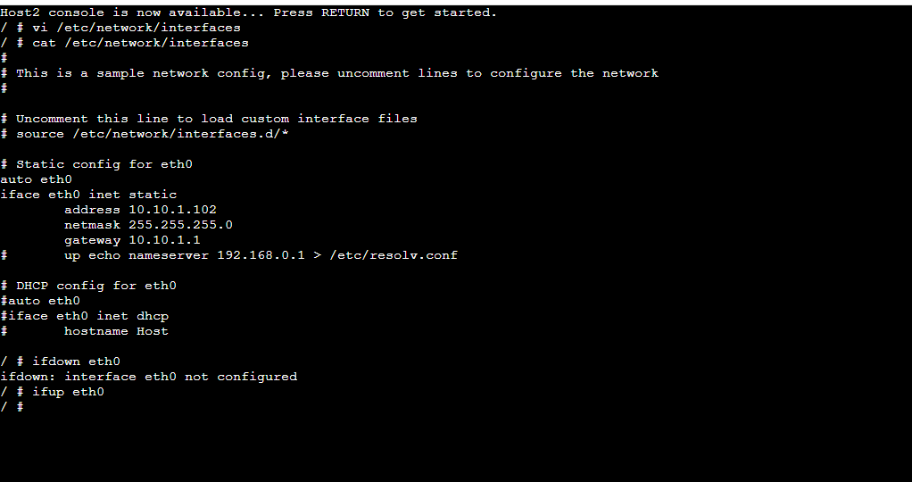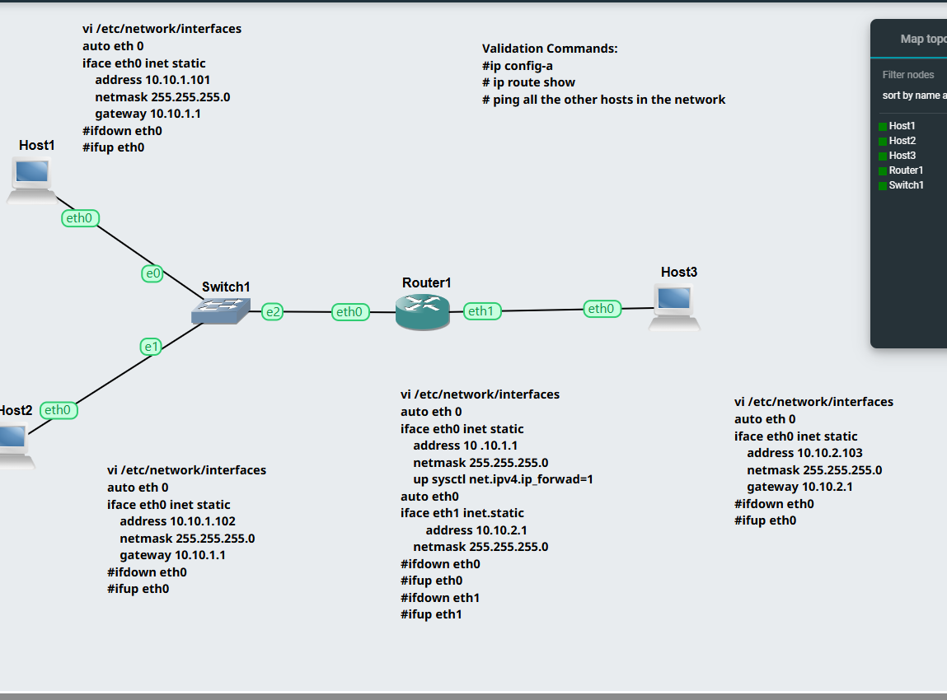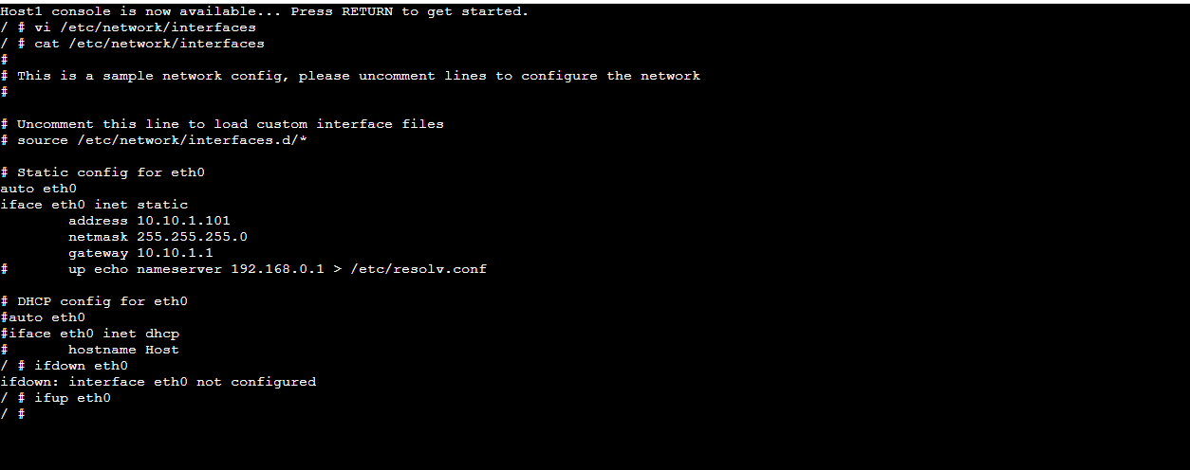

Task 2: Dynamic Routing with OSPF

Aim
To observe how OSPF dynamically updates routing tables and adapts to network changes.

Topology Description
The network consists of multiple FRR routers (FRR1–FRR4), two hosts, and two NETem links. There are multiple paths between the source and destination networks.

OSPF Configuration
OSPF is pre-configured on all routers. Each router advertises its connected networks using OSPF area 0.

Neighbour Routers
Using "show ip ospf neighbor", neighbouring routers were identified. Routers formed FULL adjacency states, confirming proper OSPF communication.

Routing Table Observation
Using "show ip route" and "show ip ospf route":
- Directly connected networks were visible.
- OSPF learned routes showed next-hop routers.
- Multiple paths existed for some destinations.
Screenshots of all tasks 2:
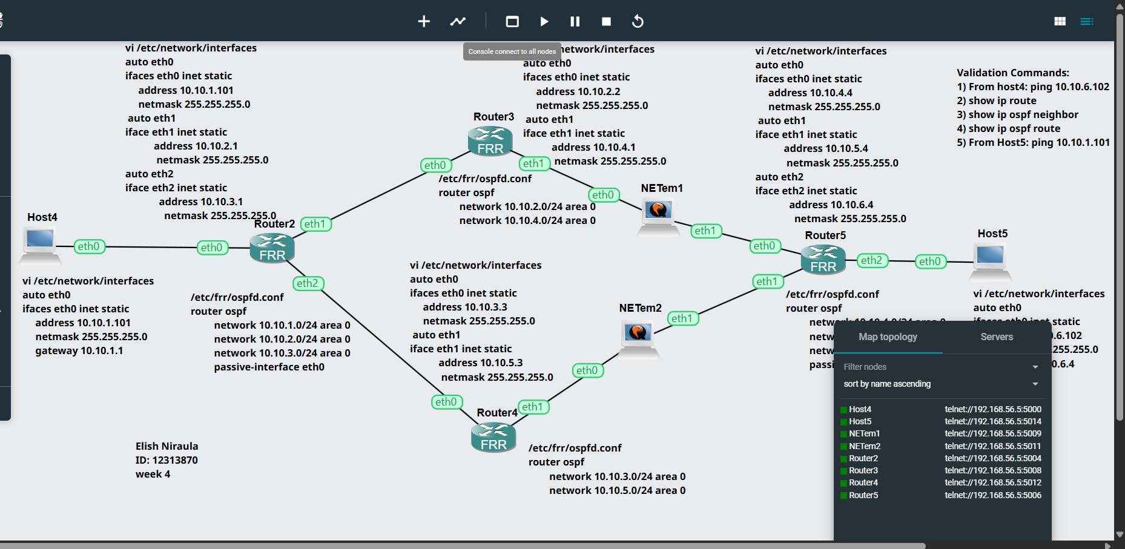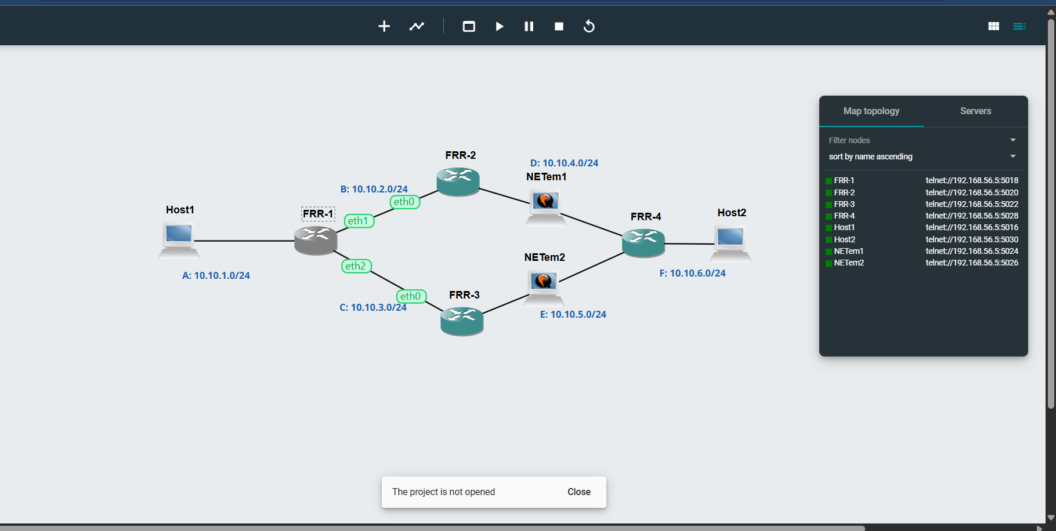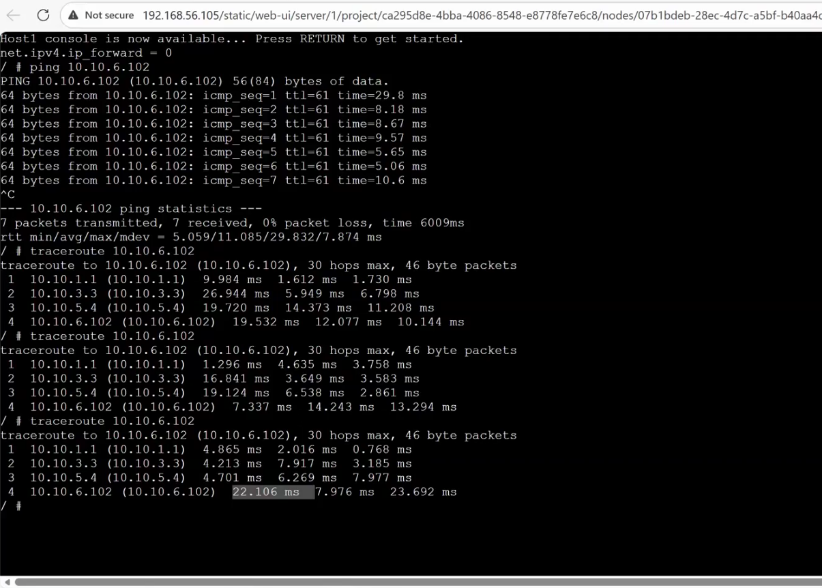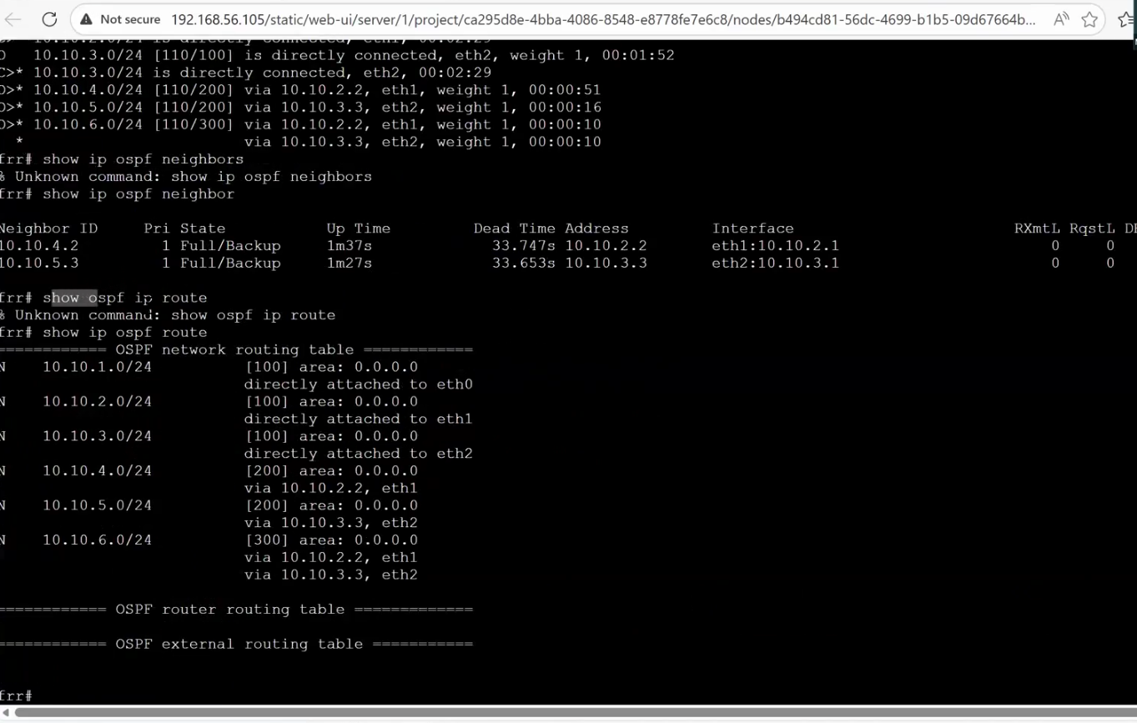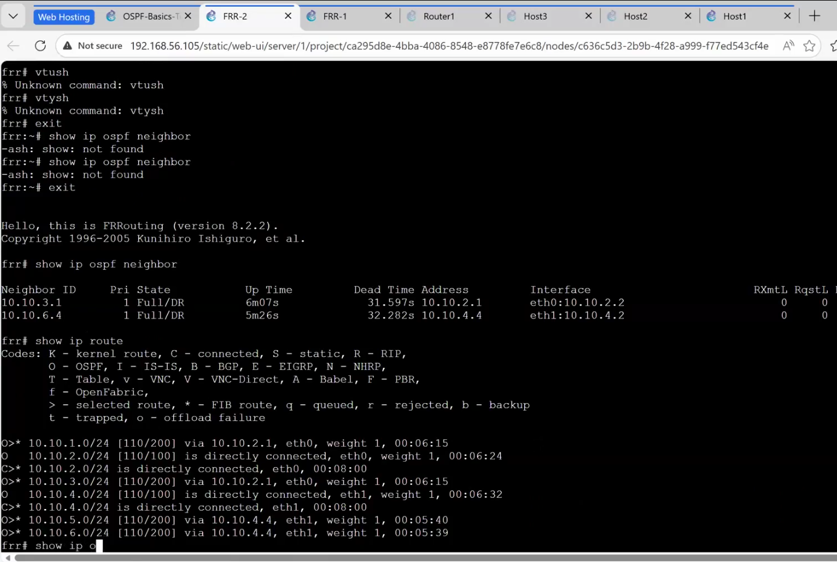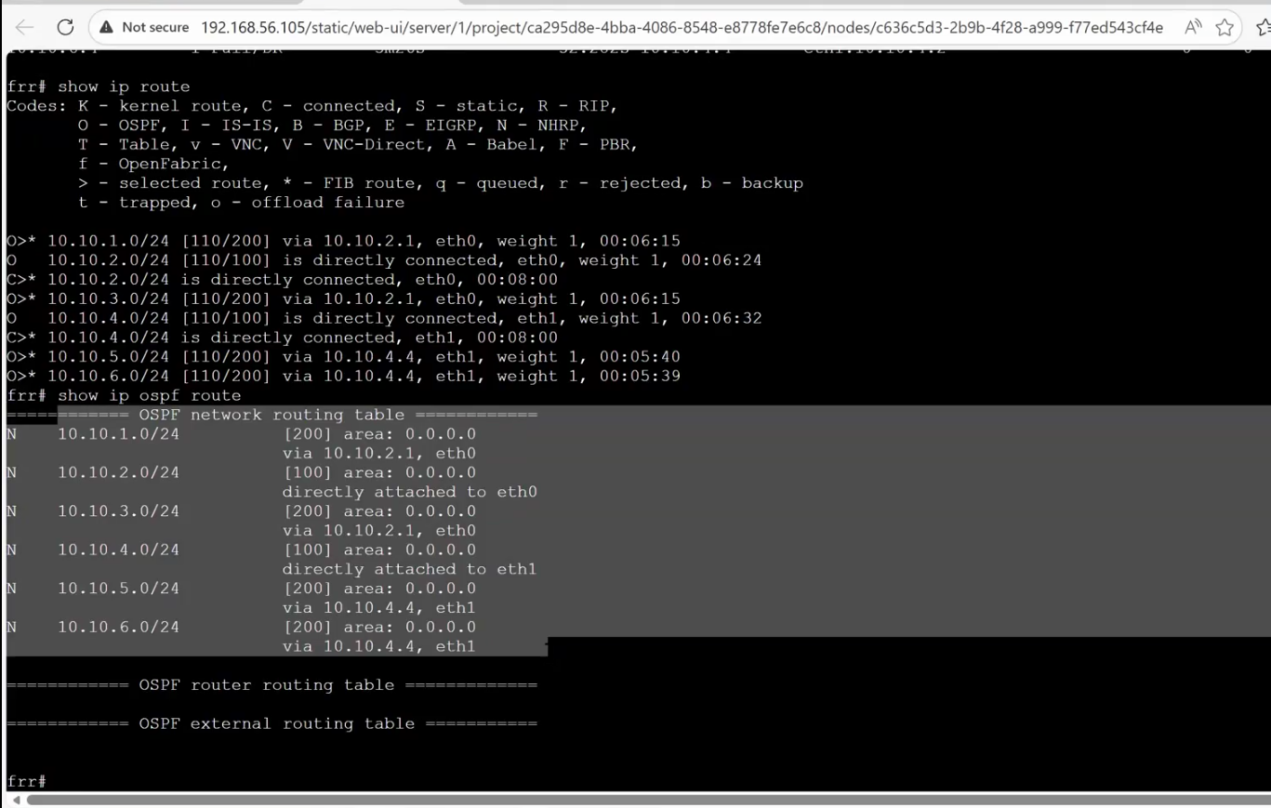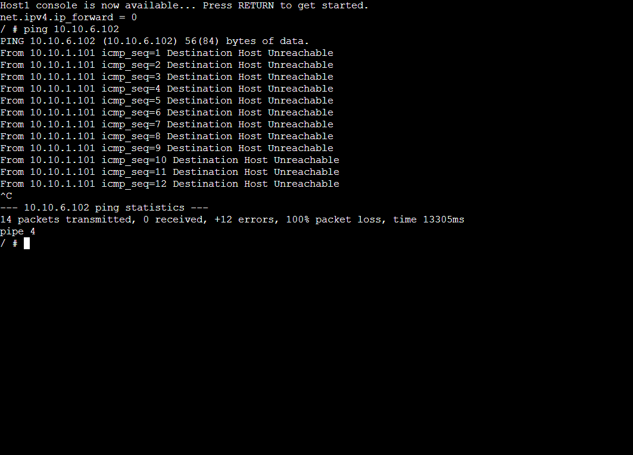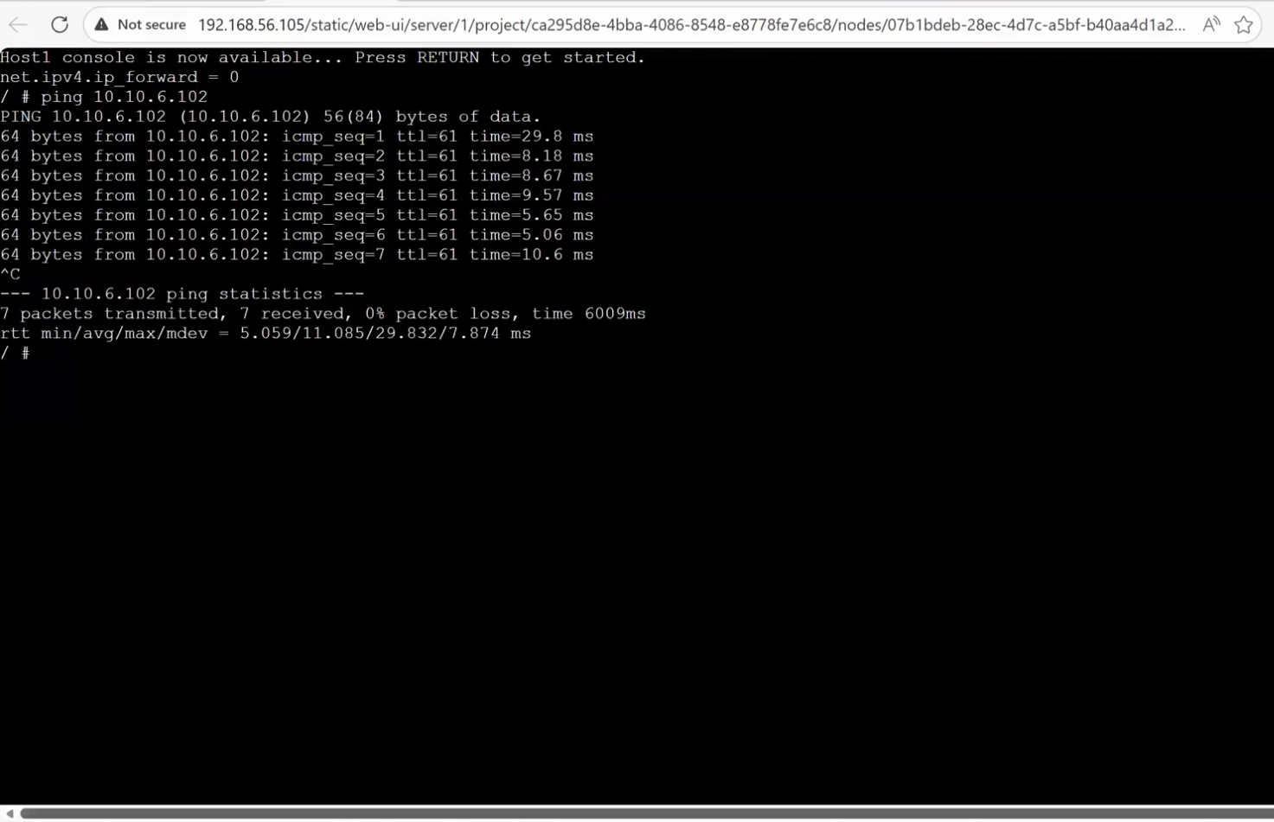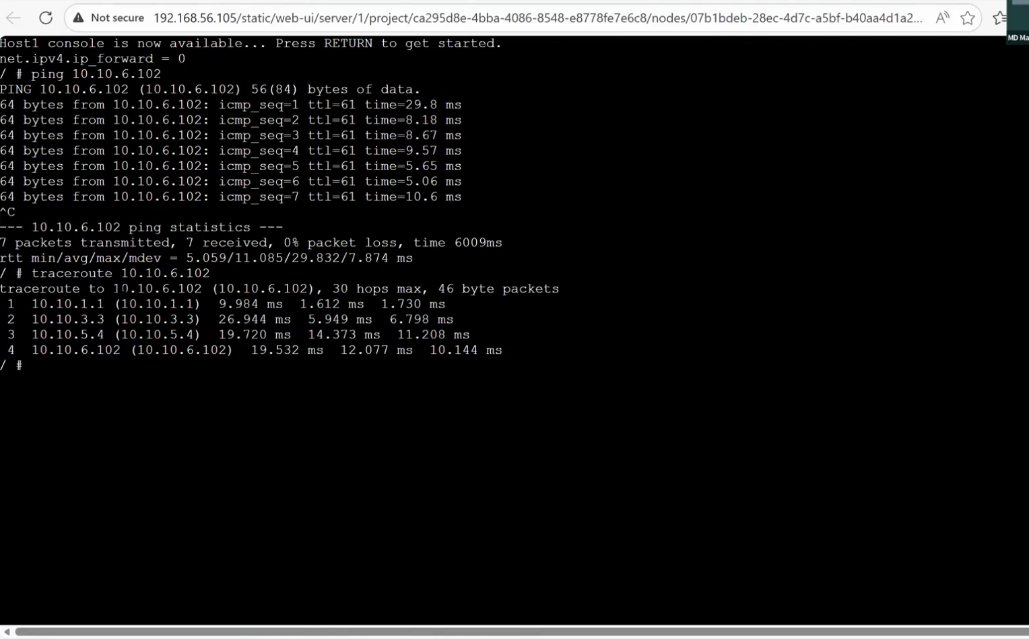

Ping test from host 1 to host 2.

Traceroute Analysis
Traceroute was used to identify the path from source to destination.
Initial path:
Host1 → Router1 → Router3 → Router5 → Host2
After link failure:
OSPF recalculated and traffic was redirected through an alternate path.

Ping Results
Initially ping failed due to incomplete routing.
After OSPF convergence, ping was successful with 0% packet loss.

Conclusion
OSPF automatically adapts to network changes by recalculating routes. This ensures reliable communication even when links fail.

